Name:- Harpal Singh

Assignment:- 9

**Web API to an existing Application**

In this we have taken web API based application. Where controller and model has been incorporated. This project is for the company where there are multiple employees. Company as convince allowance give petrol or diesel to its employees. This project has included two modules.

1. Clerk allocating the slip to the employee.
2. Store people who mark those people who has taken the fuel against the slip.

It includes open interface. Because It is back office process. There requires less security perspectives.

1. **Home Page**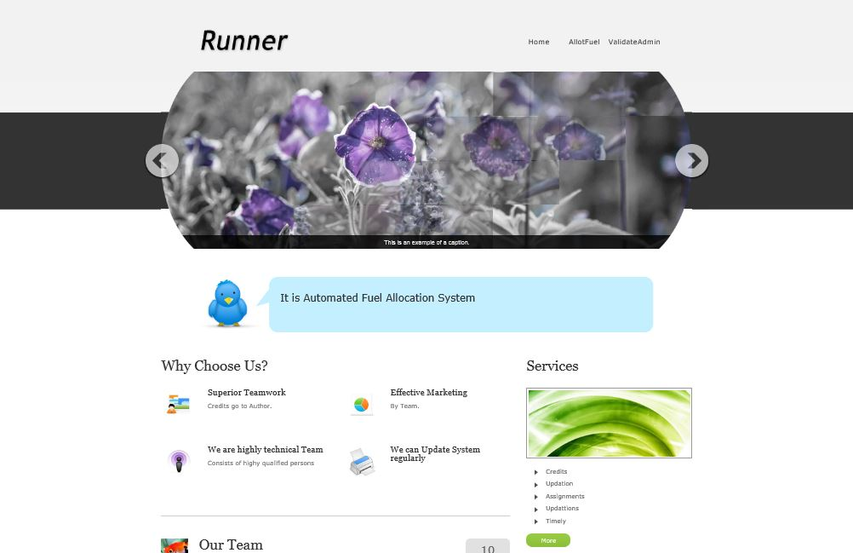it includes top level navigation bar where there are three links 1. Home, 2 is allot fuel to employee,3. Validate the slip.
2. **Allot the fuel report**

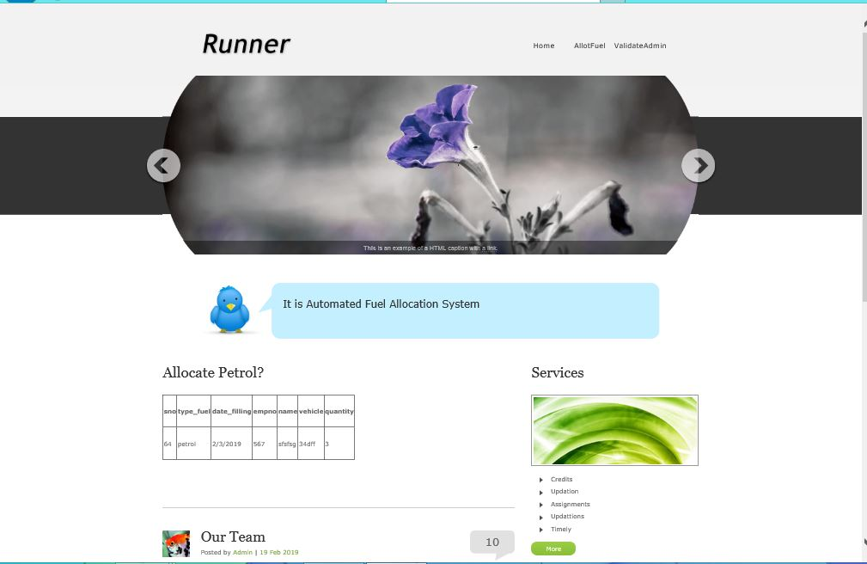

It includes various types of server side fields which will be entered to database for permanent record. Also printable slip will be generated. It will be generating two copies of the slip. One is for employee and other is for the fuel station.

1. **Addfuel.**

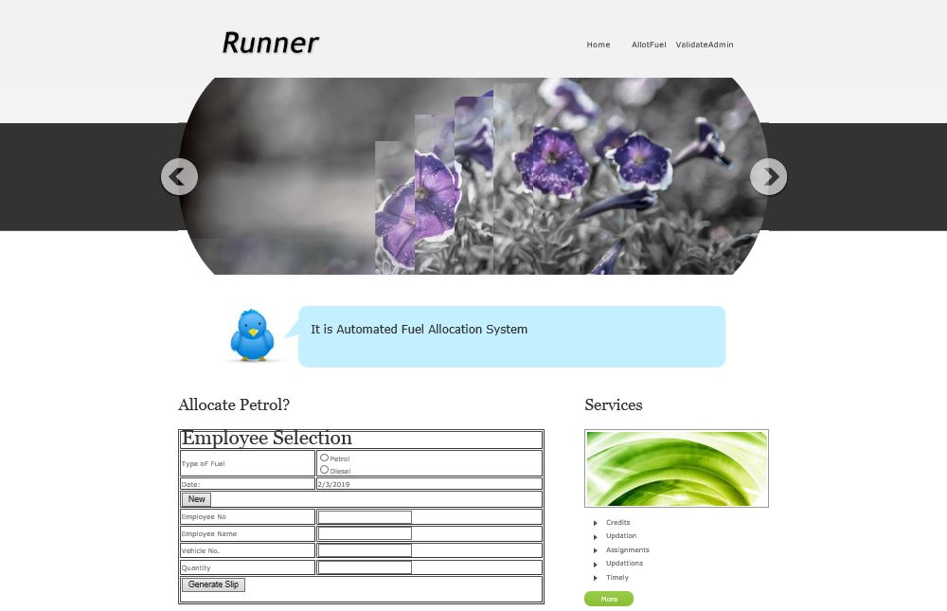

This panel will shoes the entries of those employees who has taken the slip for a given date. Store can validate the entry.

1. **Validated report**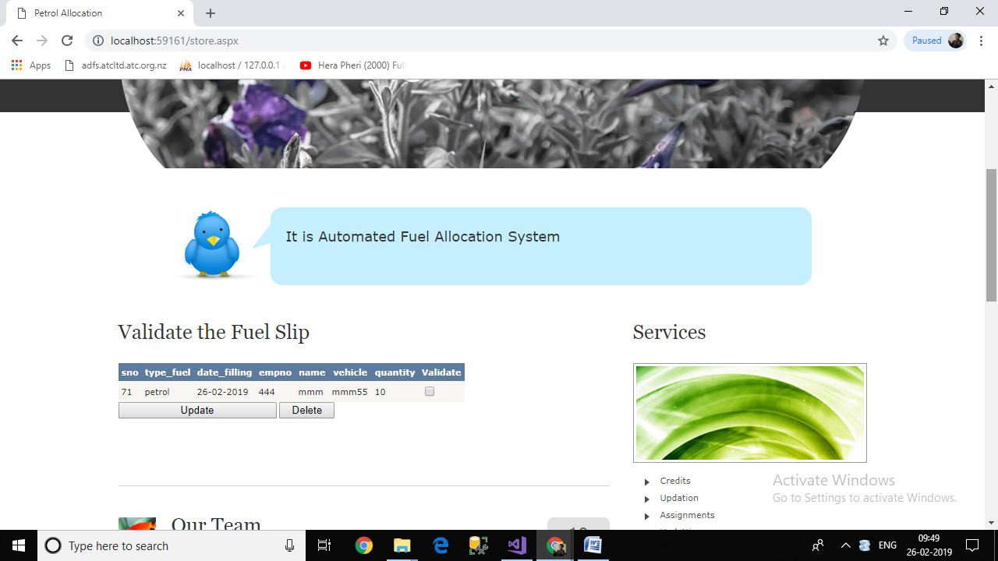

It will shows the date wise details of the employee who has been validated.

**Web API**

[ASP.NET](http://asp.net/) Web API is a powerful platform for building HTTP enabled service APIs that expose service and data. It can be consumed by a broad range of clients including browsers, mobiles, desktop and tablets. As it is HTTP service, so it can reach a broad range of client.

[**ASP.NET**](http://asp.net/)**Web API** is very much similar to [ASP.NET](http://asp.net/) MVC because it contain  the [ASP.NET](http://asp.net/) MVC feature like routing, controllers, action results, filter, model, etc. Note [ASP.NET](http://asp.net/) Web API is not a part of MVC framework. It is a part of the core [ASP.NET](http://asp.net/). You can use Web API with [ASP.NET](http://asp.net/) MVC or any other type of web application. You can also create a stand-alone service using the Web API.

